DOORWAY TO SIGIL 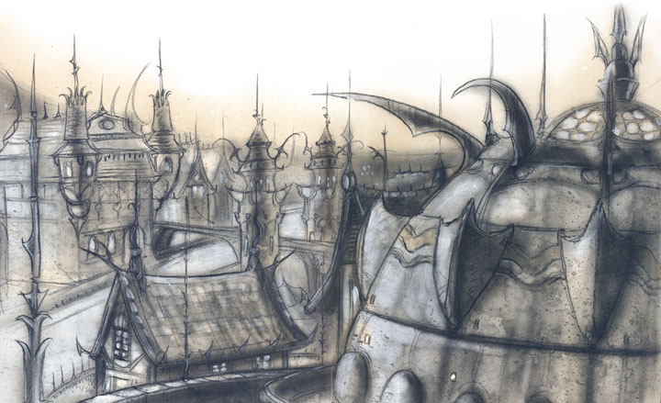
Some poets write raptures about the glories of their metropolis, sing praises about the sunset over the rooftops, and grow lyrical to the gentle clatter of their city's life - but no one sings that way about Sigil. The Cage's a gray, wet, dirty place, full of noise and brawling, slippery stone and razorvine. Oh, there's native poets and they write about their home, but not about its glowing sunsets or walks through sweet-scented parks. They write about the things that shouldn't be seen in the dark alleys, about the way the street rumble like a pit of dying beasts, or about the decay that cleanses the bones of the city.
Hey, Sigil's a long way from being a stinking pit - don't make the mistake of thinking it's not a grand and majestic place. It's far better than Malbolge or Khin-Olin on the Lower Planes. It's got more life than the patrolled city-states of Arcadia. Sigil's filled with the life only a truly neutral haven can offer.
And that's just the point: Everybody comes to Sigil - the good and the evil, those warring and those at peace, the just and the cruel - everybody. Nobody forgets their loves or hatreds here, but for a few moments they barely manage to set them aside. A deva really might share a drink with a fiend, even if each is watching the other for signs of treachery. Nobody trusts their enemies, but all are forced to trust the laws of the Lady of Pain
Maybe it's a lie, though, that everyone comes to Sigil, because there's one important group that can't: the deific powers of the planes. There's something about Sigil that shuts them out, locks the doors, and keeps them away. 'Course, the gods aren't used to having their powers denied, and that frustrates them to no end. Indeed, the mere fact that Sigil refuses their will makes them hunger for it all the more. Any Sensate'll confirm that desire is greatest for that which is denied.
That's why the powers' proxies and priests come to the City of Doors, instructed and eager to subvert Sigil's resistance from the inside. In the Cage's back alleys and shadowed dives, they play out the endless pairings of the kriegstanz, the undeclared war for the soul of Sigil. There's more players in this game than a sod can count, and the sides shift like quicksilver on glass. The sides flow like slippery beads, one to another, as the balance changes ever so slightly.
It's never an open war, though, because the Lady'd never allow it. Rather, it's a dance where the soldiers are in mufti, the battlegrounds are unmarked, and the victorious never hold up their triumphs for all to see. So long as the battle is fought discreetly, it's tolerated. Let it get out of hand and the Lady has special punishments, reserved for those berks who draw her gaze.
Because there's a rough peace here, Sigil's the place to do all types of business. Need to meet with the enemy, but can't find safe ground? Need to swap hostages from the Blood War? Got a treasure too suspicious to sell on the open market? Need some information about the enemy? Come to Sigil! Just remember to always keep your back to the wall.
So that's it: Sigil the Wondrous, Sigil the Dangerous, Sigil the Impossible. It's a city where a cutter can be anything he wants, where he can find the answer to every need. All it takes is asking the right questions. 'Course, a berk's better off not asking if he can't deal with the answers, because sometimes what a sod wants to know ain't what he learns...
Sigil's Portals
Like it's been said before, Sigil's the City of Doors, the seam through space where a thousand pathways caress and couple before plunging back into the planes. The right gate keys and the right doors unlock the mysteries of her form and reveal to a cutter all the possibilities Sigil's got to offer. Pass through a door properly and a basher's enfolded in the brilliant glory of Mount Celestia, but use her the wrong way and a berk'll plunge into the icy clutches of Baator, or worse.
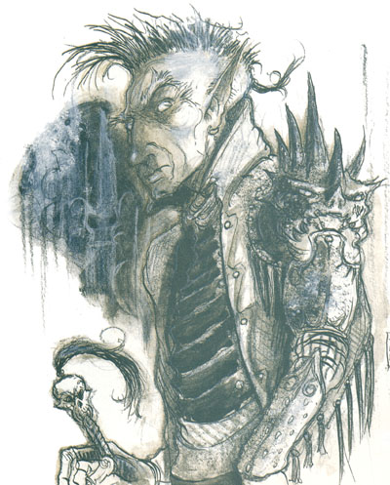
The only truth is this: Step through a keyed portal and a cutter'll end up somewhere. (Whether he likes the destination or not's another matter - Sigil opens her doors to those with the key, but she don't promise a warm embrace.)
Pure fact is there's only one way in or out of Sigil, and that's through the portals that link it to everywhere. Sigil can't be entered by a gate spell, and although a berk can reach the Outlands through the Astral Plane, Sigil itself is shielded, so tricks like the astral spell don't work. The Cage can't be entered or spied upon by astral travelers, either. At the same time, Sigil's not completely cut off from the Astral Plane. Spells requiring an astral connection (like raise dead) still work; it's only the actual passing or viewing that's obstructed.
In Sigil, all portals anchor themselves on doors, arches, or openings of some type. Suitable apertures include windows, arches, sewer entrances, even wardrobes and chests - pretty much anything a cutter can step through might be a portal. They're always big enough for a normal being to fit through, even though he might have to duck or worm through the opening to do it.
Most randomly occurring, non-permanent portals to other planes are doors in deserted back alleys in the worst parts of town, or at least it seems like they're always in the worst parts of town. That's because there's a spell, that can shield areas from portals. High-up folks got the jink to pay for these, keeping their cases and neighborhoods free of portals - and safe from intruders -while poor folks don't. (The biggest concentration of portals has got to be in the Hive, probably the worst of the worst parts of town.) If a cutter's looking for a permanent portal to a specific plane, he might check out the area near the faction headquarters whose primary plane of influence is the one he wants - most factions maintain or guard a fixed door to their favorite universe.
Every blood knows a true seeing spell's a means to look at a thing and know it's a portal - the only time a detect magic spell can reveal one is when it's actually working. Short of wandering the streets with a true seeing spell in operation, though, the special spell warp sense is the best means of finding a portal. Warp sense's got an advantage over true seeing, too, since it gives some idea of where the other end's going to be. Most of the factions can teach a wizard the way of this spell, provided he's in good standing with his factol.
Portals are two-way deals. Step through one way and a cutter can step back the other, if he's still got the gate key to open the door. This means that folks can get into the Cage as easy as they can leave, so there's no guarantee that running for the safety of Sigil's going to keep a sod safe from his enemies. 'Course, the Lady of Pain can always shut doors to folks as she pleases, but most often this means that portals don't work for any of the powers. Sometimes she locks out other threats to her realm, yet she doesn't do that very often because for the most part she doesn't care who or what comes through the doors, so long as they don't make too much trouble. That counts for you too, unless you're very bad news!
Portal Types
Sure I've got a key
to this gate. It's right
there in your hand.
- Mickee Shafthamer
of the Fated
There's three kinds of portals - permanent, temporary, and shifting - but whatever the type, a cutter's got to have a gate key before the portal'll do anything. Without the key, a portal's nothing more than a doorway into a tavern, an arch over a street, or a manhole to the sewers.
Permanent portals are the most straightforward. Both ends - the opening in Sigil and the receiving end on another plane - don't change. Every time a cutter steps through, he knows just where he's going to end up.
Temporary portals appear, get used once or twice, and then disappear.
Shifting portals are the most wicked of the lot, because just when a berk gets to thinking he can depend on them, they change. Sometimes it's the Sigil end that shifts, moving from doorway to doorway in the city, and sometimes it's the other end, out on the planes, that moves. There's only one thing constant about them: The portals don't shift randomly -that'd make them no different from a temporary portal. Instead, they move from point to point in a pattern of their own. A shifting portal might cling to the arched entrance of the Hive for three days, then move to a grated outflow of the sewers for a week, before settling on the gate to a petty merchant's house for a day. After this it would repeat the cycle all over again. Outside the Cage, a portal might appear outside Malbolge on Baator for three days, then jump to Arcadia for another week, and then return to Baator, to run the sequence all over again.
In Sigil, bloods with an ear for the chant'll keep elaborate logs of every appearance, every shift. For some portals the pattern's easy, a few changes over a few days. For others the pattern's like a code that's never broken. A sod can see it's there, but he can't read the message.
Gate Keys
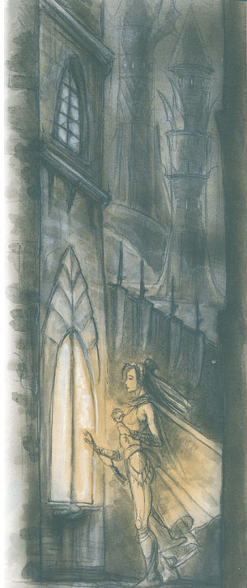
Getting a portal to work needs a gate key, which is always a thing that's carried through the opening.
One way for you to learn the gate key needed for a particular portal is by asking the relevant faction (which could be tricky cause they won't always have the knowing of it or share it). A warp sense spell gives a clue toward what key's needed, as does a contact higher plane or legend lore spell. Furthermore, there's shops in Sigil, like Tivvum's Antiquities, that do nothing but sell items needed for gate keys. Need a pearl to get to the Elemental Plane of Water? They've got one for a price. (Like all good businesses, they're in it to make a profit.) But once a cutter gets a key, things are pretty well set, because the key for a portal never seems to change.
Armed with the right gate key, a body can make any portal work. He just carries the item across the threshold and the portal automatically comes to life. It only stays open for a few seconds, just long enough for up to six folks to step through, provided they're ready. The archway flashes with golden dazzles, and whatever's at the other end can be seen as a ghostly image. Those stepping through vanish from Sigil as they cross the threshold, appearing at their destination in the same instant.
Aside from the portals, Sigil's physically cut off from the rest of the multiverse. Astral and other plane-hopping spells just don't open into the place. The Guvners guess that being at the heart of the Outlands creates some kind of astral barrier around the Cage. Seeing as there's no other answer, that sounds pretty reasonable to most folks who care about such things. The important thing to remember is that portals and portals alone are the only way to enter and exit Sigil.
The Realities of Impossibility
Get it right out front: Sigil's an impossible place, especially to primes who go barmy when 2+2 don't make 4. A city built on the inside of a tire that hovers over the top of a gods-know-how-tall spike, which rises from a universe shaped like a giant pancake... it happens all the time, right? 'Course not, but who cares?
Describing Sigil
If one could describe the place with words, the closest prime-material analogy is an auto tire. Imagine a tire lying on its side. Sigil would be built on the inside of the tire. All the streets and buildings would fill the curved interior. Meanwhile, on the outside there's nothing.
No matter where a cutter stands, if he looks up he's going to see buildings overhead. Most of the time a basher's looking across the center of the ring, so he'll see a broad panorama of the city in the distance (unless, of course, it's obscured by smoke, smog, fog, or rain). Locals get used to having the gray arc constantly hovering overhead; in fact, the open sky of a normal world sometimes unnerves them.
Another important thing to remember is that the city's curved in the opposite direction from most prime-material worlds. On those worlds, there's a horizon because the surface has a convex curve, and a cutter can only see what lies along a straight line of sight. In Sigil, things curve up, not down. Looking down a long avenue, it'll seem like the street's rising in front of a body, kind of like looking up a long hill. Just to make it more confusing, Sigil curves both in front of and behind that sod on the street, so he might feel like he's standing at the bottom of a big hollow nearly all the time. The Cage's a flaming big city, though, and it's crowded tall with people, buildings, and smog. The average line of sight is rarely more than a few hundred feet unless a body's looking straight up, so it's not like a berk's constantly looking at the curve of a bowl all around him. It might be a few hours before the average prime, new in town, realizes that the world ain't flat.
Up And Down
"Down" is always the ground beneath a cutter's feet, no matter where he's standing on the ring. Up is the other direction. It doesn't take much to realize that two bashers on opposite sides of the ring could both look "up" at each other. Flying across the ring's perfectly possible, and so is falling. A berk always falls toward the section of Sigil closest to him, even if he was headed in another direction to start with. Although the shapes are different, the whole business is really no different than tailing on any Prime world: A sod falls, he gets hurt. Along with "up and down" is the question of inside and outside." It's quite a question, too. Nobody's ever seen the outside of Sigil because there may not even be an "outside." The edges of the ring are all solidly lined by buildings with no windows or doors on their backs. 'Course, a cutter could get himself up on the roof to take a look. Those that've tried It'll tell a body, "There's nothing to see," and they really do mean "nothing" - not emptiness, not a vacuum, just nothing. That matches what flyers say lies Beyond the ring: nothingness.
Humans being a particularly curious type, it's natural that some of the barmies have tried stepping off into the nothingness. Everybody who does so just vanishes.
Day And Night
There's day and night in Sigil, but it's not caused by a sun. Instead, the sky gradually fills with luminescence until it reaches a peak and then immediately begins to fade. There's both bright daylight and deep darkness, but most of Sigil's day is a half-light, the gloom of twilight, rich with shadows and haze. Things sensitive to sunlight can get around without problem for all but the brightest six hours of every day (the three before and after peak). ; Sigil doesn't have a moon or stars. The Cage's without stars, of course, but there's still lights in the sky. Remember, the city's always overhead, so even in the darkest hours there'll be the sharp lights of far distant lanterns.
Weather
Rain and smog - that pretty much says everything about Sigil's weather. The city's sky is mostly a greasy-looking haze from the smoke and fumes that belch from a thousand chimneys. When it rains - which it does a lot - the rainwater's got a brownish tinge from all the crud that's scrubbed from the sky. When it's not raining, there's an equally good chance that a thick, foglike smog has settled over the city. Visibility can be as bad as only 5 feet in the worst of these, but most times a cutter can see about 10 yards through the haze.
When it isn't drizzling brown water or swaddled in fog, Sigil can be a pretty pleasant place. The temperature tends to be cool (chilly when it's raining), and light breezes blow away the stagnant odor that normally hangs in the air. Still, no cutter ever comes to Sigil for the climate.
Razorvine
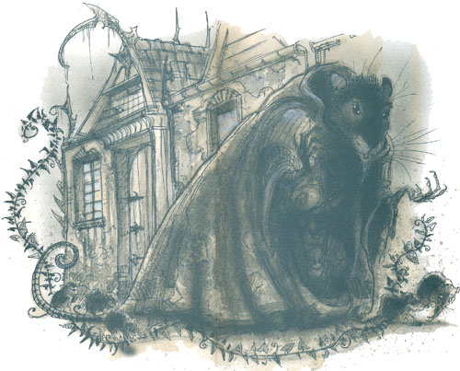
Sigil's a far cry from a lush wilderness, but it does have its share of wildlife, all brought in from elsewhere. Plant life's pretty slim, though. There used to be a city park, but it's mostly overrun by squatters. The only lasting contribution to the flora of Sigil is razorvine - not most berks' idea of a blessing. Razorvine's a hazard and a pretty nasty one at that, but since it can't get up and chase a sod around, it's easy for most to avoid. Razorvine's got no special powers or intelligence, it doesn't harbor evil thoughts, and it couldn't lure even the dimmest leatherhead into its leaves. About the only thing it does is grow, but it does that very well. Plain said, razorvine's the kudzu of the Outer Planes. It used to just grow on the Lower Planes, where it fit in, but over time it's spread into all sorts of places, like Sigil.
Razorvine got its name because that's what it is: a twining climber whose lush, glossy black leaves conceal blade-sharp stems. A cutter can't touch it with his bare hands without getting slashed. Once more, the razor edges are so fine, they'll slice through cloth and cheap leather, too. Properly cured leather or something like a chain mail mitt's the only safe way to pick the cursed weed. Anybody really wanting to grow the stuffs going to suffer for their folly at the least.

The Lady of Pain
The high-up man in Sigil, the one who ultimately watches over the Cage, is the Lady of Pain. She's not a woman and she's not human - nobody's quite sure what she is. The best guess is she's a power, probably a greater power, but there's also a theory that she's a reformed tanar'ri lord, if such a thing's possible. Whatever else she is, she's the Lady of Pain, and given that, most other facts are extraneous.
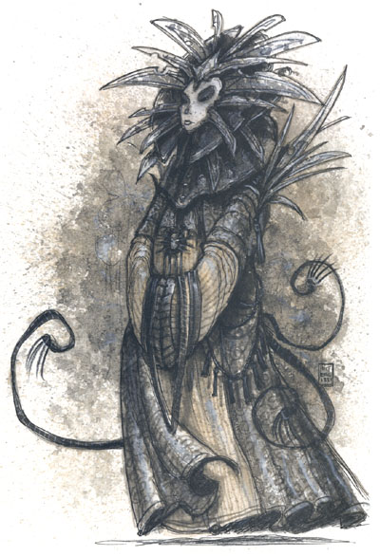
For the most part the Lady (as she's called) keeps distant from the squalid hurly-burly of the Cage. She doesn't have a house, a palace, or a temple. Nobody worships her, and with good reason: Those that say prayers to her name get found with their skins flayed off - a big discouragement to others.
Sometimes she's seen drifting through the streets, the edge of her gown just brushing over the cobblestones. She never speaks. Eventually, her image fades and she vanishes into nothingness. Natives of Sigil view her with fearful awe, as she's the uncaring protector of their home.

The Mazes
The Mazes are the grandest of all Sigil's punishments, and the Lady of Pain saves them for the worst threats to her power. They're a part and yet not a part of the city, and no sane basher wants to go there. The Mazes are the Lady's special birdcages for the would-be power mongers of Sigil.
The Mazes are just that: mazes.
A sod sentenced to the Mazes never knows it until it's too late. Sometimes they form around him just as he's passing through some particularly deserted part of the city; he turns a corner and the next intersection's not the way he remembers it, and by that time it's too late.
The Dabus
The dabus are both servants and lords of Sigil. They're unique to the Cage, never found anywhere else in the planes. In other words, the dabus never leave Sigil. From this, bloods figure the dabus are actually living manifestations of the city, which makes sense since the beings maintain most of the infrastructure that makes the city work.
Most of the time the dabus are found repairing what's broken in Sigil. They keep the sewers and catacombs beneath the streets from crumbling, they cut back the razorvine when it grows too rampant, they patch the cobblestone streets, and they repair the crumbling facades of the city's buildings. To most, the dabus are nothing more than cryptic workmen.
The Code of Conduct
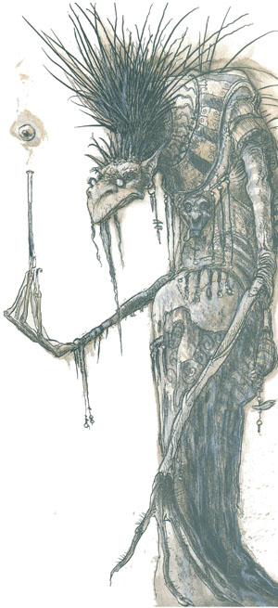
So what's a blood got to do to avoid the Lady's attention? What are the laws of Sigil?
There aren't many.
Sigil's a place where anyone and anything can happen, and a lot of it does. The Lady of Pain's not interested in the petty squabbles of day-to-day affairs. A murder here, a mugging there - that's not her concern because the Harmonium can take care of it.
It is possible to get put in her dead-book for less than Sigil-shattering deeds, though. All a berk's got to do is make the folks of Sigil question the Lady's power. Too many killings or crimes'll make the folks of Sigil nervous and fearful, and they'll start wondering if she's got the means to protect them.
It'd seem natural that the factions would always be threatening the Lady's power, too. After all, each one's got their own idea of just what's proper and right for Sigil, and these are ideas that don't always include the Lady of Pain at the top of things. Fact is, if they go too far she'll crack them like beetles. Now, the factols are wise enough to see that Sigil's a safe haven from their enemies, besides being the best way to get around, and no faction wants to get itself spun out of Sigil.

